**DRIFTERS MOTORCYCLE CLUB MEMBER PROFILING AND NOTIFIER SYSTEM**

**Statement of the problem:**

1. The Identity and aims of the club has poor amount of exposure to the public.
2. Leaders and admins of the Club members has difficulty of reminding each members of the current events
3. Difficulty of Spreading the Schedule of the Rides of each member of the group
4. Club members has difficulty of knowing the club’s next Destination

**Stability of the Project:**

Nowadays people or clients tends to advertise their group in order to gain more members and followers. There is difficulty in exposing the groups and clubs to the society, especially if the group has just started not long enough to be recognized by the society. This system will help the client need in exposing the group on publicity and gain more members so that the group will grow larger and more stable, also to have a good reputation on the world motorcycle clubs. This system will also help the client’s members be notified whenever this is an incoming event or incoming ride. Also it will also guide incoming members about the rules, club status and officials of the club.

**Scope and limitation:**

This website will be accessed by Visitors and members can only view the current events, schedules, pictures, videos and rules of the website. Each visitors can view the current events, schedules and moments that has or will happened in the club.

However it doesn’t have an account that is made for visitors or members, instead there will be a maintenance website that has an account that leaders and assign members has the privilege. Leaders will maintain the inappropriate input that will not affect the users visit on the website.

**ENTITY RELATIONSHIP DIAGRAM**

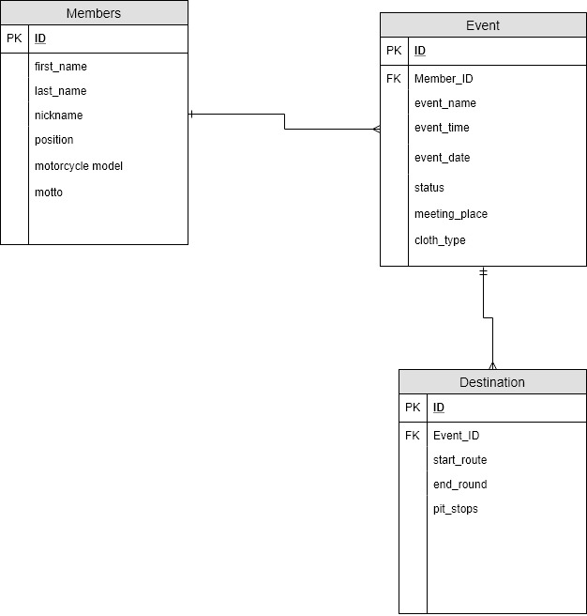

**WIRE FRAME**

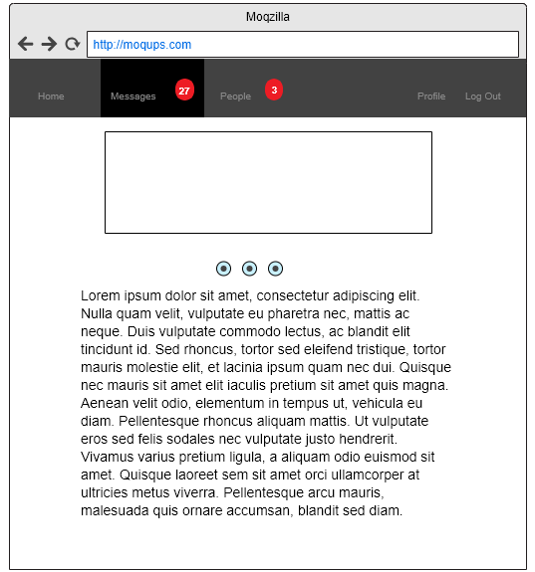

HOME PAGE

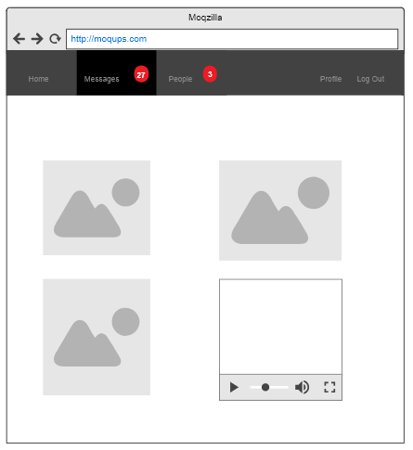

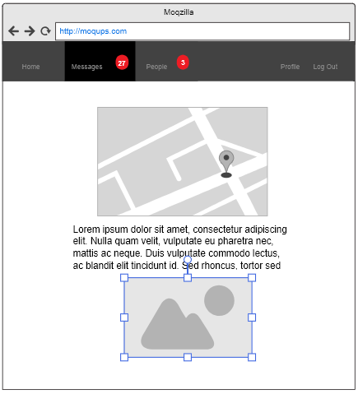

MAP DESIGNATOR AND LOCATOR PAGE

GALLERY PAGE

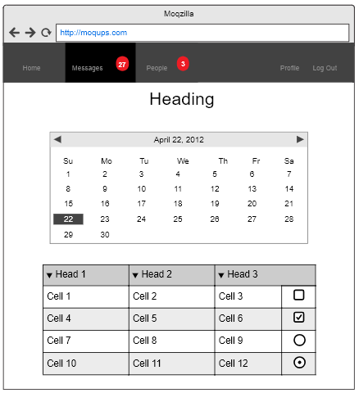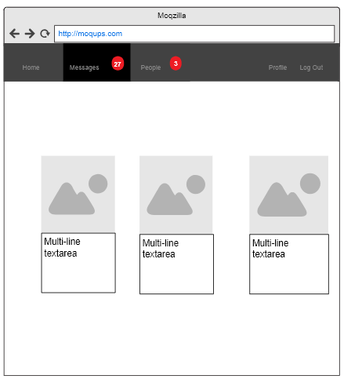

EVENT SCHEDULE PAGE

OFFCIALS AND MEMBERS PAGE

SAMPLE OF THE PROJECT

